VISVESVARAYA TECHNOLOGICAL UNIVERSITY

BELGAUM



**DATABASE MANAGEMENT SYSTEM**

**LABORATORY MINI-PROJECT REPORT**

**ON**

**ATM/CDM SYSTEM**

SUBMITTED BY

**DEEPAK V GAUTHAM N**

**1AT15CS020 1AT15CS023**

Submitted in partial fulfillment of the requirement for the award of the

Degree of Bachelor of Engineering

In

Computer Science &Engineering

UNDER THE GUIDANCE OF

**Prof. Rajendra M**

**Asst. Professor**

**Atria Institute of Technology**

**Anandanagar, Bangalore-560024**



**Atria Institute of Technology**

**Anandanagar, Bangalore-560024**

# CERTIFICATE

This is to certify that the project entitled “**ATM/CDM SYSTEM**” has been successfully completed by

**DEEPAK V GAUTHAM N**

**1AT15CS020 1AT15CS023**

In partial fulfillment for the data base management system laboratory with mini-project report[15CSL58] –V semester, BE Computer Science during2016-2017.

Signature of guide Signature of HOD

Prof. Rajendra M Dr. P. Aishwarya

**External Viva:**

(Name of Internal/External Examiner with signature & Date)

Examiner 1____________________________

Examiner 2____________________________

# ACKNOWLEDGEMENT

Any achievement, be it scholastic or otherwise does not depend solely on the individual efforts but on the guidance, encouragement and cooperation of intellectuals, elders and friends, who believe that the individual can excel and put in their every bit in every endeavor he/she embarks on, at every stage in life. And the success is derived when opportunity meets preparation, also supported by a well-coordinated approach and attitude.

The joy and satisfaction that accompanies the successful completion of any task would be incomplete without mentioning the people who made it possible and also whose efforts gave this project its final shape.

We would like to express our gratitude to our respected principal **Dr. K V Narayanaswamy** for providing a congenial environment and surrounding to work in. We would like to express our sincere gratitude to **Dr. P. Aishwarya, Head of the Department, Computer Science& Engineering**, for his continuous support and encouragement.

We are indeed indebted to **Prof. Rajendra M,** project guide and lab in-charge, for is support, advice and inputs in the course of this project. We would also like to thank various faculty members of the Computer Science & Engineering Department for their valuable suggestions and inputs.

Last, but not the least we would like to thank our parents, who have acted as a beacon of light throughout life.

Our sincere gratitude goes out to all our comrades and well-wishers who have supported us through all our ventures.

**DEEPAK V GAUTHAM N**

**1AT15CS020 1AT15CS023**

# ABSTRACT

**ATM/CDM SYSTEM**

The **ATM/CDM System** is the project which is used by customers to access their bank accounts in order to make cash withdrawals and cash deposits. Whenever the user need to make cash withdraws, they can enter their PIN number ***(Personal Identification Number)*** and it will display the amount to be withdrawn in the form of 100’s. Once their withdrawal is successful, the amount will be debited in their account and a Transaction ID will be displayed.

The ATM/CDM System is developed in front-end as PHP and back-end database as My SQL. PHP ***(Hypertext Preprocessor)*** is a widely used open source general-purpose scripting language that is especially suited for web development and can be embedded into HTML. Hence we used this software in our project.

The ATM/CDM will service one customer at a time. A customer will be required to enter Bank Account number and PIN – both of which will be sent to the database for validation as part of each transaction. The customer will then be able to perform one or more transactions. Also customer must be able to make a balance inquiry and generate a Mini Statement of any account linked to the Account number.

The ATM will communicate each transaction to the database and obtain verification that it was allowed by the database. In the case of a cash withdrawal, an alert with the Transaction ID will be displayed which the user can take note of. The same goes for Deposit transaction also. Any debits or credits made will be sent to the Database and changes will be reflected in the database as well.

If a transaction fails for any reason other than an invalid PIN, the ATM will display an explanation of the problem, and will then alert the customer of the error and the customer will be redirected to the Login page.

The ATM will provide the customer with an alert for each successful transaction, showing the transaction ID. When balance enquiry is selected the balance of the account of the customer is displayed. When Mini statement is selected a table showing the date, time, type of transaction, amount and available balance of the affected account

.

# 

# 1. INTRODUCTION

# 1.1 INTRODUCTION TO DBMS

A database is simply an organized collection of related data, typically stored on disk, and accessible by possibly many concurrent users. Databases are generally separated into application areas. For example, one database may contain Human Resource (employee and payroll) data; another may contain sales data; another may contain accounting data; and so on. Databases are managed by a DBMS. Many Database Systems are being used which are in turn managed by many other Database Management Systems. A Database Management System (DBMS) is a set of programs that manages any number of databases. Basically DBMS is a software tool to organize (create, retrieve, update and manage) data in a database. The main aim of a DBMS is to supply a way to store up and retrieve database information that is both convenient and efficient. By data, we mean known facts that can be recorded and that have embedded meaning. Database systems are meant to handle large collection of information. Management of data involves both defining structures for storage of information and providing mechanisms that can do the manipulation of those stored information. Moreover, the database system must ensure the safety of the information stored, despite system crashes or attempts at unauthorized access.

**1.1.1 SQL PROGRAMMING**

SQL (Structured Query Language) is a standard database programming language used to accessing and manipulating data in a database. SQL was developed In 1970 by Donald D. Chamberlin and Raymond F. Boyce at IBM. For handling database and database related programming, programmers need to have some medium or you can say interface to particularize a set of commands or codes to deal with database or to access database’s data. It is pronounced as “sequel”. SQL is the standard language for Relation Database System. SQL is used by many databases like MySQL, Oracle, SQL Server, PostgreSQL etc.

SQL statements always start with the keywords. SQL statement ends with semicolon. SQL is not case sensitive, means update is the same as UPDATE.

Structured Query Language is perhaps the most common way to extract data from a relational database system. The Basic Syntax (simplified) Format is:

SELECT field name(s)

FROM databases table name(s)

WHERE conditional clause

This is the way in which SQL programming can be used to access many number of Databases.

**1.1.2 SQL COMMANDS**

|  |  |
| --- | --- |
| **SQL Command** | **Description** |
| [CREATE DATABASE](https://www.w3schools.in/sql/create-database/) | Creates a new database. |
| [CREATE TABLE](https://www.w3schools.in/sql/create-table/) | Creates a new table. |
| ALTER DATABASE | Modifies a database. |
| ALTER TABLE | Modifies a table. |
| DROP TABLE | Deletes a table. |
| CREATE INDEX | Creates an index. |
| DROP INDEX | Deletes an index. |
| SELECT | Fetch data from a database table. |
| UPDATE | Modifies data in a database table. |
| DELETE | Deletes data from a database table. |
| INSERT INTO | Inserts new data into a database table. |
|  |  |

# 1.2 BRIEF OUTLINE OF THE PROJECT

The ATM/CDM System is a simulated working of an **Automated teller machine/Cash deposit machine**.

The front end tool used to simulate this software database is My SQL. When a user enters his account number and his PIN he will be able to log into his Account. This is achieved by sending the login information to the database and verifying whether the credentials are matching the database records. If it matches the records then the user is able to login to his account to perform any transaction. Else he’ll be required to enter his credentials properly again.

After he has access to his account he can choose between 5 options which are:

1. Withdraw cash.

2. Deposit cash.

3. Enquire balance.

4. Generate a Mini Statement.

5. Change PIN Code.

Any of the option can be chosen choose based on his requirement. If he chooses Withdraw cash option then he will be redirected to a page where he can select if he wants to Withdraw from his Savings account or a Current account. Then he can enter the amount he wishes to withdraw and if the balance is sufficient in his account the transaction will be successful, else he will be redirected back to the login page with an alert that he has insufficient funds in his account. The amount entered should be in multiples of 100s only. The amount which is withdrawn will be updated in the database of the account holder. A transaction ID will be generated and presented to the user, which he can make note of. This is the same case of operation if he chooses the 2nd option which is the Deposit operation in which case he can deposit money into his account.

When the 3rd option that is, Enquire Balance is chosen, the user is presented with a page to choose between his savings account and his current account and that account’s balance is displayed on a new page. This balance will be the current balance pulled from the database.

When the 4th option that is, Mini Statement is chosen, the most recent 8 transactions of that account holder will be presented in the form of a table. The tuples of the table are Date, Time, Transaction number, Account Number, Account Type, Amount, Balance and Transaction Type. All of this tuple details will be pulled from the database and presented to the user.

The final 5th option is Change PIN option in which the user can change his account PIN Code by entering his Old PIN code, New PIN code and verifying his new PIN code. This information is sent to the database and the PIN code change is reflected in the database as well.

This a Brief outline of how the project operates.

# 2. REQUIREMENT SPECIFICATIONS

# 2.1 EXTERNAL INTERFACE REQUIREMENTS

**2.1.1 USER REQUIREMENTS**

The interface provided to the user should be a very user-friendly one and it should provide an optional interactive help for each of the service listed. The interface provided is a menu driven one and the following screens will be provided:-

1) A login screen is provided in the beginning for entering the required username/pin no. and account number.

2) An unsuccessful login leads to a reattempt screen to again enter the proper information. The successful login leads to a screen displaying a list of supported options from which a user can select any one.

3) After the login, a screen with a number of options is then shown to the user. It contains all the options along with their brief description to enable the user to understand their functioning and select the proper option.

4) A screen will be provided for the user to perform various transactions in his account such as cash withdrawals/deposits, check balance, change PIN etc.

5) A screen will be provided for user to withdraw cash or another screen to deposit cash which will also generate a Transaction ID post a successful transaction.

6) A screen will be provided for user to check his account balance.

7) A screen will be provided where the user should be able to generate a Mini Statement with about 8 recent transactions listed.

The following reports will be generated after each session dealt with in the machine: 1) Login time and Logout time along with the user’s pin no and account number is registered in the database.

2) The ATM’s branch ID through which the session is established is also noted down in the database.

3) Various changes in the user’s account after the transactions, if any, are reported in the database.

4) An alert is generated for the user displaying all the transactions he performed.

**2.1.2 SOFTWARE REQUIREMENTS**

The software that needs to be installed in order to run this software are XAMPP server software(In which Apache server is needed to run the PHP/HTML interface and My SQL database to store all the information), any web browser such as Google Chrome to open the website interface. Using these 2 software’s is sufficient to run this software system.

# 2.2 FUNCTIONAL REQUIREMENTS

There are a few functional requirements for this system to work. They are:

1. The account information must be validated before the user can access his account information to carry out any transactions.
2. Valid errors must be provided if account number or PIN is incorrect.
3. A cancel button must be present in every screen so that the user can terminate the session at any point.
4. A menu with all the available transactions should be displayed on a screen for a user to select from.
5. The keypad must accept input from the user.
6. The withdraw option must check if sufficient funds are available in a user’s account before proceeding with the withdrawal transaction.
7. The amount entered must be in multiples of 100s and this must also be checked by the system.
8. A transaction ID must be generated for each transaction that takes place.
9. Account balance information must be updated after each transaction takes place

10) Mini Statement must be generated of at least 5 recent transactions and must be

presented in the form of a table.

11) User must be able to change his PIN code successfully which must also be

updated in the database.

12) After a successful transaction, it must be redirected back to the start page.

These are few of the functional requirements of the project.

# 3. SYSTEM DESIGN

This section describes how the system has been designed.

## 3.1 E-R DIAGRAM

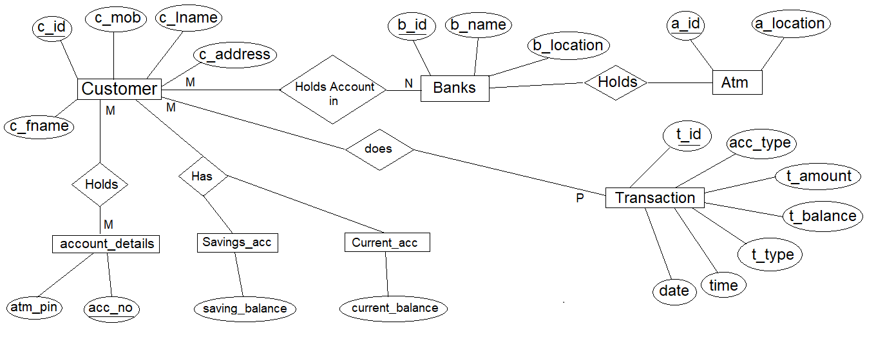

This is the Entity-Relationship diagram which has been used to create our Database.

## 3.2 USER INTERFACE DESIGN

The user interface used in any software must be user friendly. So, we have made PHP/HTML interface as our Front-end tool. PHP is being widely used in this era of web development. It is simple, user-friendly and HTML can be embedded within it.

To access PHP files we needed a server which is why we have used XAMPP server software which consists of Apache Server. By using this software we were able to access all our PHP pages and work on it. We used Sublime Text 3 software to code our webpages. This open-source tool can be used to code about 200 programming and scripting languages together. Finally with the help of XAMPP server software we were able to create a Database in Microsoft’s MySQL database. All the data required to run this system is stored in that database. It is highly convenient for developers and designers alike to connect MySQL database data and PHP webpages using simple SQL command queries. We also made use of online resources such as [www.w3schools.com](http://www.w3schools.com) and [www.stackoverflow.com](http://www.stackoverflow.com) to help us learn about PHP and other scripting languages. Any user can use our web interface and easily be able to sign-up, login to his account, make any desired transaction and exit the system with a Transaction ID (As long as its successful).The entire sequence of our web interface has been detailed in Section 7 with the help of which anyone can better understand our approach to a Simple yet Powerful User Interface design.

# 4. DETAILED DESIGN

This section describes the design of the database in detail such as how the database has been created, what SQL commands are used, what kind of constraints are placed on those identifiers or variables, what kind of data types are defined etc.

## 4.1 DATABASE CREATION

A database is simply an organized collection of related data, typically stored on disk, and accessible by possibly many concurrent users. Databases are generally separated into application areas. The database that is in-use in this system is MySQL database within XAMPP software. The database was created with reference to the above E-R Diagram. A database can contain data from many different data types and all of this data can be retrieved using SQL commands.

SQL Commands used to create the Database of this system are:

CREATE TABLE banks (b_id integer primary key, b_name varchar (20), b_location varchar (20));

CREATE TABLE atm (a_id integer primary key, a_location varchar (20));

CREATE TABLE customer(c_id integer,b_id integer references banks(b_id) on delete cascade,c_fname varchar(20),c_lname varchar(20),c_address varchar(30),c_mob integer, PRIMARY key(c_id, b_id));

CREATE TABLE account_details(c_id integer references customer(c_id) on delete cascade, acc_no varchar(20), atm_pin integer, primary key(acc_no, c_id));

CREATE TABLE current_account(c_id integer primary key references customer(c_id) on delete cascade, current_balance integer);

CREATE TABLE saving_account(c_id integer primary key references customer(c_id) on delete cascade, saving_balance integer);

CREATE TABLE transaction (t_id integer, c_id integer references customer (c_id) on delete cascade, t_amount integer, t_type varchar (10), primary key (t_id, c_id);

### 4.1.1 DATA DEFINITIONS

A **Data Definition** is a syntax similar to a computer [programming language](https://en.wikipedia.org/wiki/Programming_language) for defining [data structures](https://en.wikipedia.org/wiki/Data_structure), especially [database schemas](https://en.wikipedia.org/wiki/Database_schema).

There are many Data Definitions. The ones that are used in this project are:

* **CREATE** Statement:

The *create* command is used to establish a new database, table, index, or [stored procedure](https://en.wikipedia.org/wiki/Stored_procedure).

A commonly used *CREATE* command is the *CREATE TABLE* command. The typical syntax is:

CREATE TABLE *[table name]* ([*column definitions]*) *[table parameters]*

* **UPDATE** Statement:

The UPDATE statement is used to modify the existing records in a table.

Typical syntax of this statement is:

UPDATE *table_name*  
SET *column1* = *value1*, *column2* = *value2*, ...  
WHERE *condition*;

* **INSERT INTO** Statement:

The INSERT INTO statement is used to insert new records in a table.

INSERT statement can be written in 2 ways. Basic syntax is:

The first way specifies both the column names and the values to be inserted:

INSERT INTO *table_name* (*column1*, *column2*, *column3*, ...)  
VALUES (*value1*, *value2*, *value3*, ...);

If you are adding values for all the columns of the table, you do not need to specify the column names in the SQL query.

INSERT INTO *table_name*  
VALUES (*value1*, *value2*, *value3*, ...);

* **SELECT** Statement:

The SELECT statement is used to select data from a database.

The data returned is stored in a result table, called the result-set.

The basic syntax is:

SELECT *column1*, *column2, ...*  
FROM *table_name*;

### 4.1.2 CONSTRAINTS

SQL constraints are used to specify rules for the data in a table.

Constraints are used to limit the type of data that can go into a table. This ensures the accuracy and reliability of the data in the table. If there is any violation between the constraint and the data action, the action is aborted.

Constraints can be column level or table level. Column level constraints apply to a column, and table level constraints apply to the whole table.

The Constraints used in this Project are:

* [**PRIMARY KEY**](https://www.w3schools.com/sql/sql_primarykey.asp) - A combination of a NOT NULL and UNIQUE. Uniquely identifies each row in a table
* [**FOREIGN KEY**](https://www.w3schools.com/sql/sql_foreignkey.asp) - Uniquely identifies a row/record in another table
* [**NOT NULL**](https://www.w3schools.com/sql/sql_notnull.asp) - Ensures that a column cannot have a NULL value
* [**UNIQUE**](https://www.w3schools.com/sql/sql_unique.asp) - Ensures that all values in a column are different

## 4.2 STORED PROCEDURES

## 4.3 TRIGGERS

# 5. DATABASE CONNECTIONS & CODE IMPLEMENTATIONS

## 5.1 RETRIEVING DATA FROM DATABASE

## 5.2 INSERTING DATA INTO DATABASE

## 5.3 UPDATING RECORDS INSIDE DATABASE

# 6. SYSTEM TESTING

**Levels of Testing:**

Systems are not designed as entire systems nor are they tested as single systems. The analyst must perform both unit and system testing.

* **Unit Testing:**

In unit testing the analyst tests the programs making up a system. For this reason, unit testing is sometimes called program testing. Unit testing gives stress on the modules independently of one another, to find errors. This helps the tester in detecting errors in coding and logic that are contained within that module alone. The errors resulting from the interaction between modules are initially avoided. The test cases needed for unit testing should exercise each condition and option.

Unit testing can be performed from the bottom up, starting with smallest and lowest-level modules and proceeding one at a time. For each module in bottom-up testing a short program is used to execute the module and provides the needed data, so that the module is asked to perform the way it will when embedded within the larger system.

* **System Testing:**

The important and essential part of the system development phase, after designing and developing the software is system testing. We cannot say that every program or system design is perfect and because of lack of communication between the user and the designer, some error is there in the software development. The number and nature of errors in a newly designed system depend on some usual factors like communication between the user and the designer; the programmer's ability to generate a code that reflects exactly the systems specifications and the time frame for the design.

Theoretically, a newly designed system should have all the parts or sub-systems are in working order, but in reality, each sub-system works independently. This is the time to gather all the subsystem into one pool and test the whole system to determine whether it meets the user requirements. This is the last change to detect and correct errors before the system is installed for user acceptance testing. The purpose of system testing is to consider all the likely variations to which it will be subjected and then push the system to its limits.

Testing is an important function to the success of the system. System testing makes a logical assumption that if all the parts of the system are correct, the goal will be successfully activated. Another reason for system testing is its utility as a user-oriented vehicle before implementation.

**System testing consists of the following five steps:**

**1) Program Testing**

A program represents the logical elements of a system. For a program to run satisfactorily, it must compile and test data correctly and tie in properly with other programs. it is the responsibility of a programmer to have an error free program. At the time of testing the system, there exists two types of errors that should be checked. These errors are syntax and logic. A syntax error is a program statement that violates one or more rules of the language in which it is written. An improperly defined field dimension or omitted key words are common syntax errors. These errors are shown through error messages generated by the computer. A logic error, on the other hand, deals with incorrect data fields out of range items, and invalid combinations. Since the logical errors are not detected by compiler, the programmer must examine the output carefully to detect them.

When a program is tested, the actual output is compared with the expected output. When there is a discrepancy, the sequence of the instructions, must be traced to determine the problem. The process is facilitated by breaking the program down into self-contained portions, each of which can be checked at certain key points.

**2) String Testing**

Programs are invariably related to one another and interact in a total system. Each program is tested to see whether it conforms to related programs in the system. Each part of the system is tested against the entire module with both test and live data before the whole system is ready to be tested.

**3) System Testing**

System testing is designed to uncover weaknesses that were not found in earlier tests. This includes forced system failure and validation of total system as it will be implemented by its user in the operational environment. Under this testing, generally we take low volumes of transactions based on live data. This volume is increased until the maximum level for each transaction type is reached. The total system is also tested for recovery and fallback after various major failures to ensure that no data are lost during the emergency. All this is done with the old system still in operation. When we see that the proposed system is successful in the test, the old system is discontinued.

**4) System Documentation**

All design and test documentation should be well prepared and kept in the library for future reference. The library is the central location for maintenance of the new system**.**

**5) User Acceptance Testing**

An acceptance test has the objective of selling the user on the validity and reliability of the system. It verifies that the system's procedures operate to system specifications and that the integrity of important data is maintained. Performance of an acceptance test is actually the user's show. User motivation is very important for the successful performance of the system. After that a comprehensive test report is prepared. This report shows the system's tolerance, performance range, error rate and accuracy.

**Special Systems Tests:**

There are other six tests which fall under special category. They are described below:

* **Peak Load Test**: It determines whether the system will handle the volume of activities that occur when the system is at the peak of its processing demand. For example, test the system by activating all terminals at the same time.
* **Storage Testing:** It determines the capacity of the system to store transaction data on a disk or in other files. For example, verify documentation statements that the system will store 10,000 records of 400 bytes length on a single flexible disk.
* **Performance Time Testing:** it determines the length of time system used by the system to process transaction data. This test is conducted prior to implementation to determine how long it takes to get a response to an inquiry, make a backup copy of a file, or send a transmission and get a response.
* **Recovery Testing:** This testing determines the ability of user to recover data or re-start system after failure. For example, load backup copy of data and resume processing without data or integrity loss.
* **Procedure Testing:** It determines the clarity of documentation on operation and use of system by having users do exactly what manuals request. For example, powering down system at the end of week or responding to paper-out light on printer.
* **Human Factors Testing:** It determines how users will use the system when processing data or preparing reports.

# 7. SCREEN LAYOUTS

**WELCOME SCREEN:**

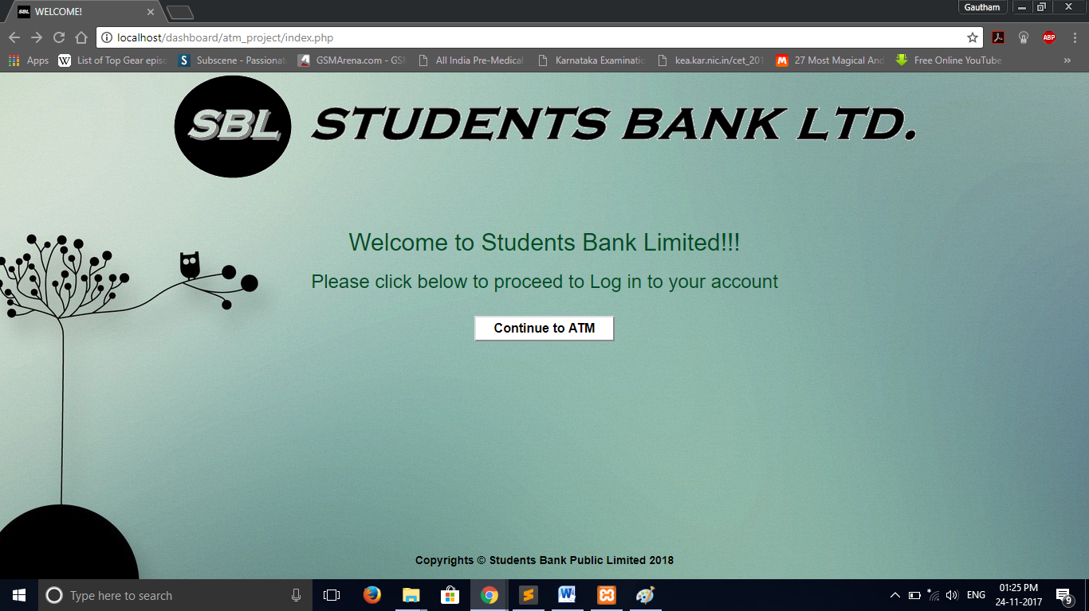

**LOGON SCREEN:**

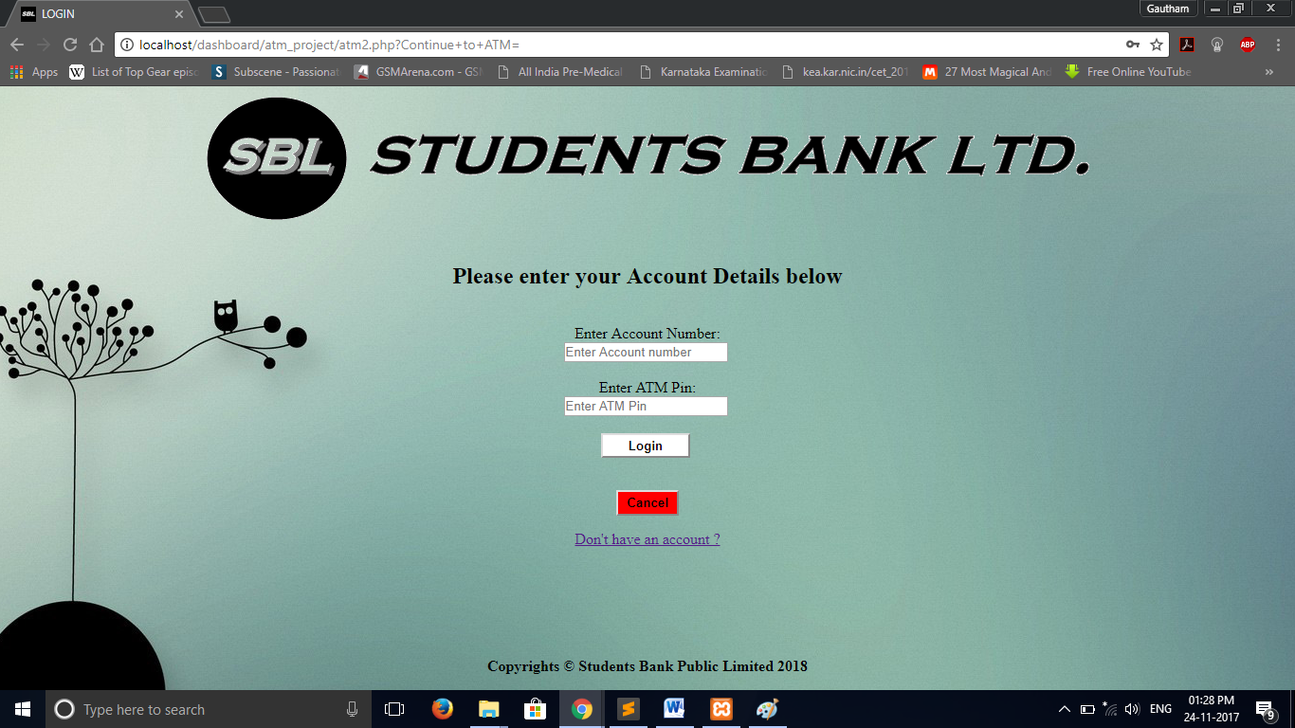

**LOGIN FAILED SCREEN:**

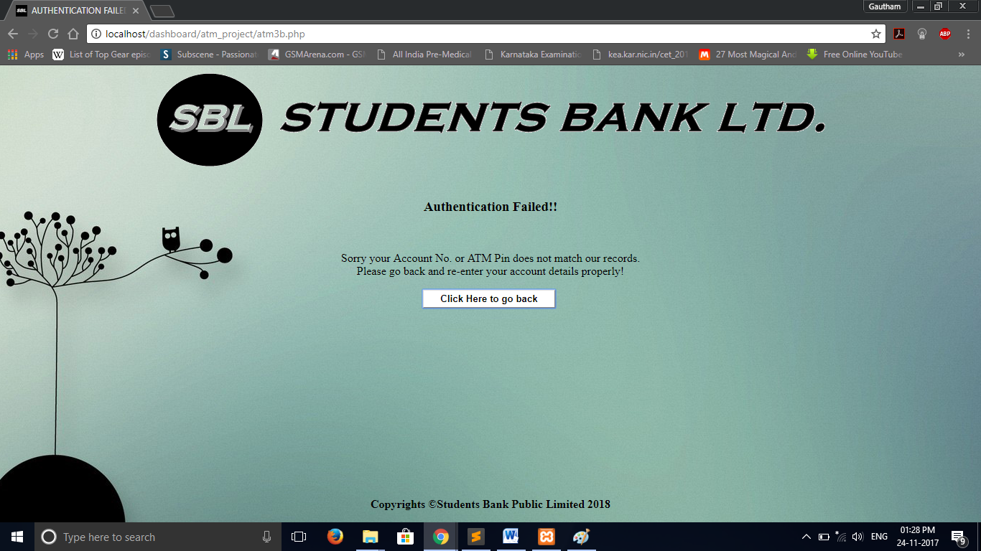

**ATM MENU SCREEN:**

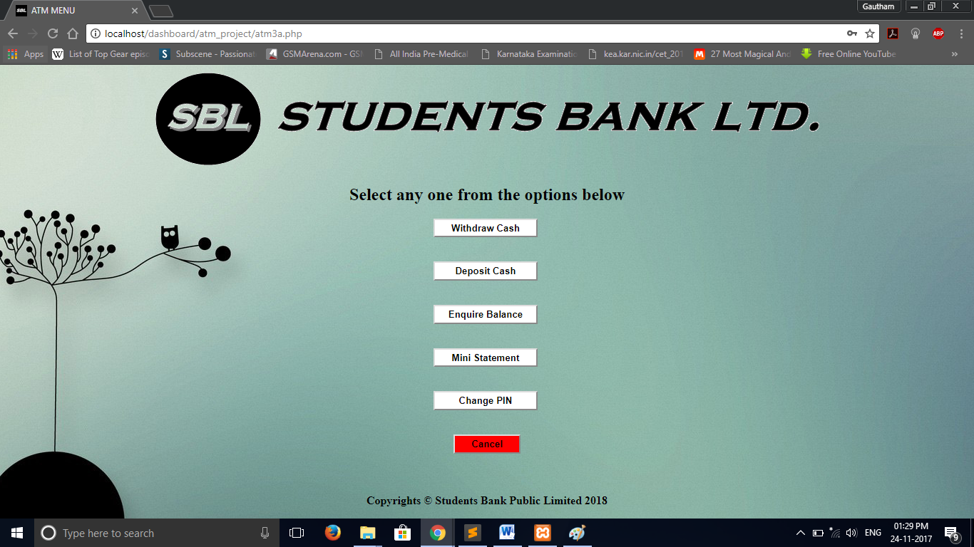

**SELECT ACCOUNT TYPE SCREEN:**

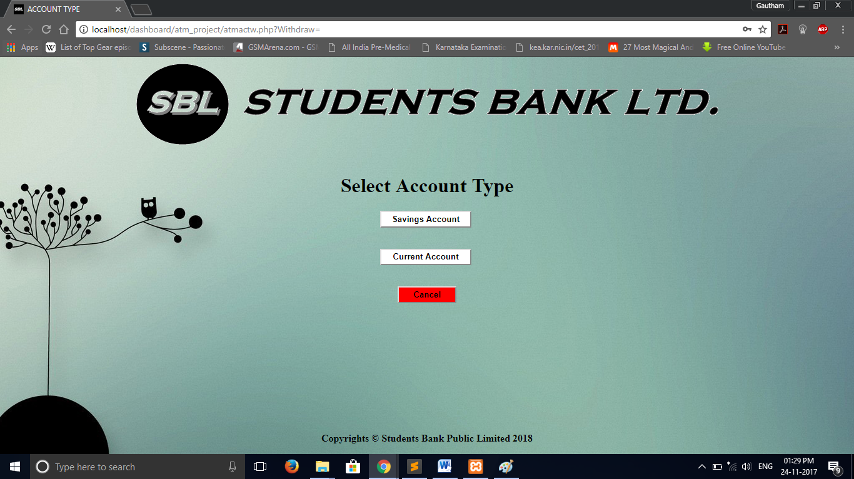

**WITHDRAW SCREEN:**

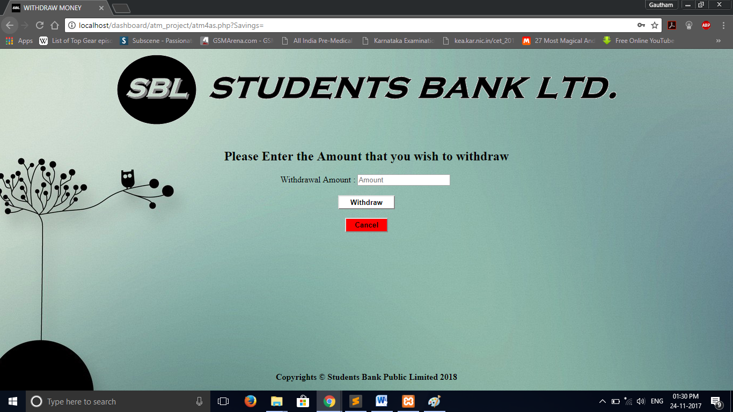

**WITHDRAW MULTIPLES ERROR ALERT SCREEN:**

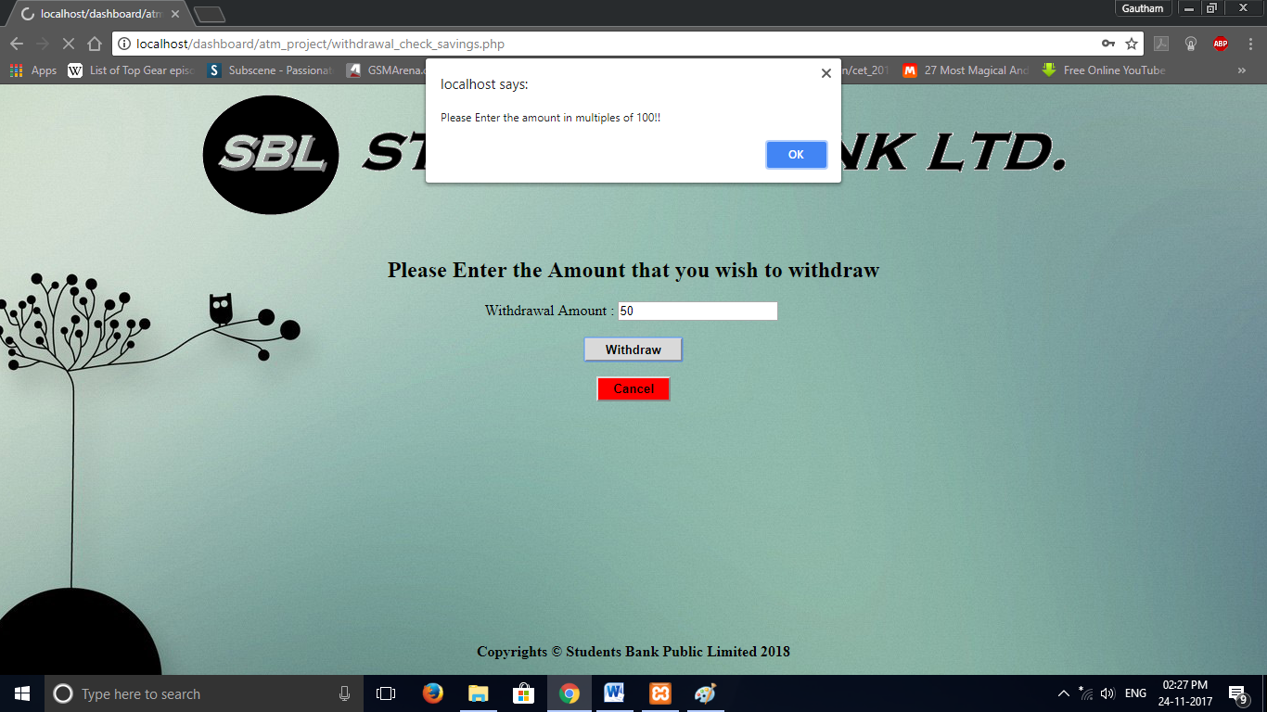

**TRANSACTION SUCCESSFUL SCREEN:**

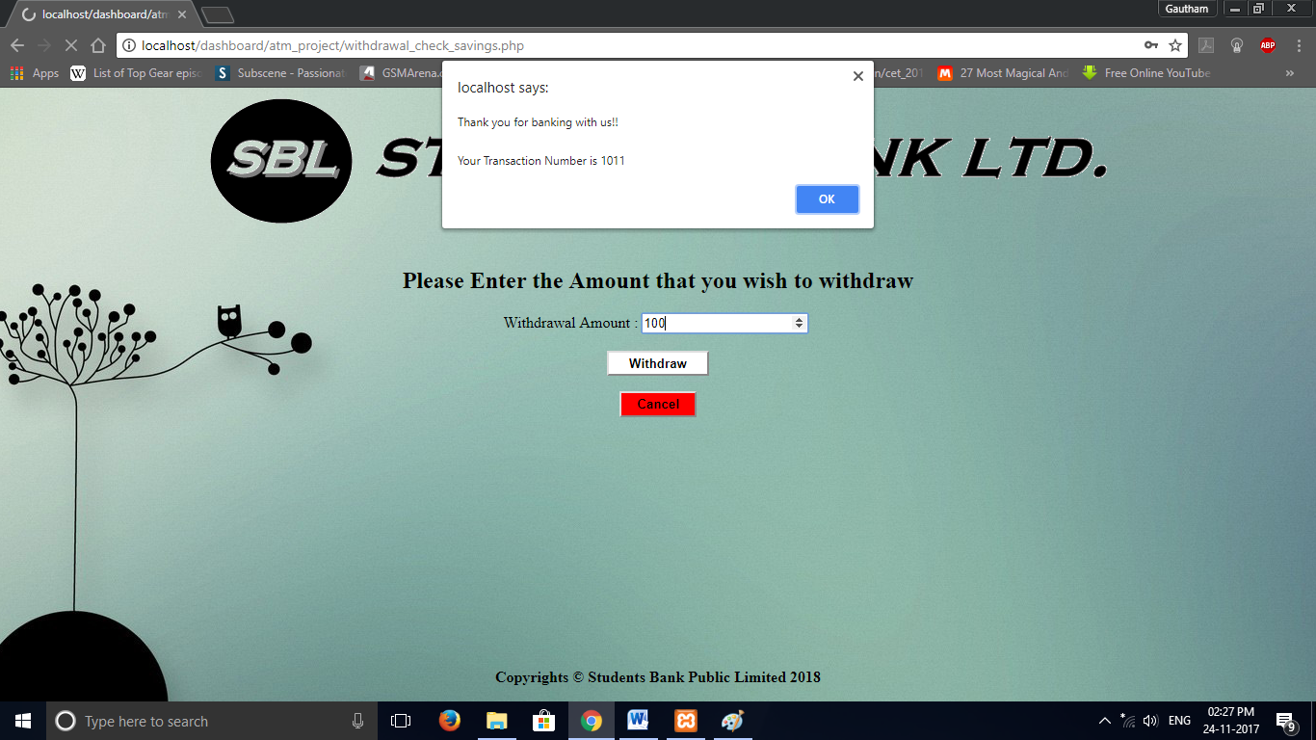

**BALANCE ENQUIRY SCREEN:**

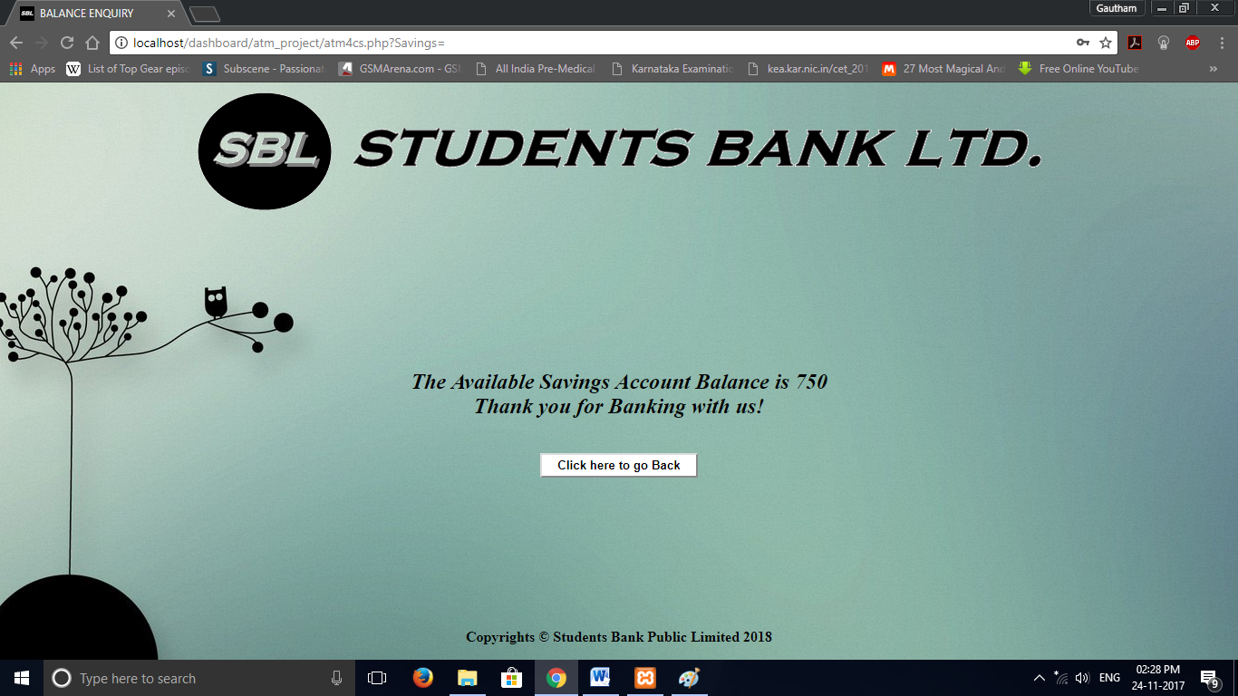

**MINI STATEMENT SCREEN:**

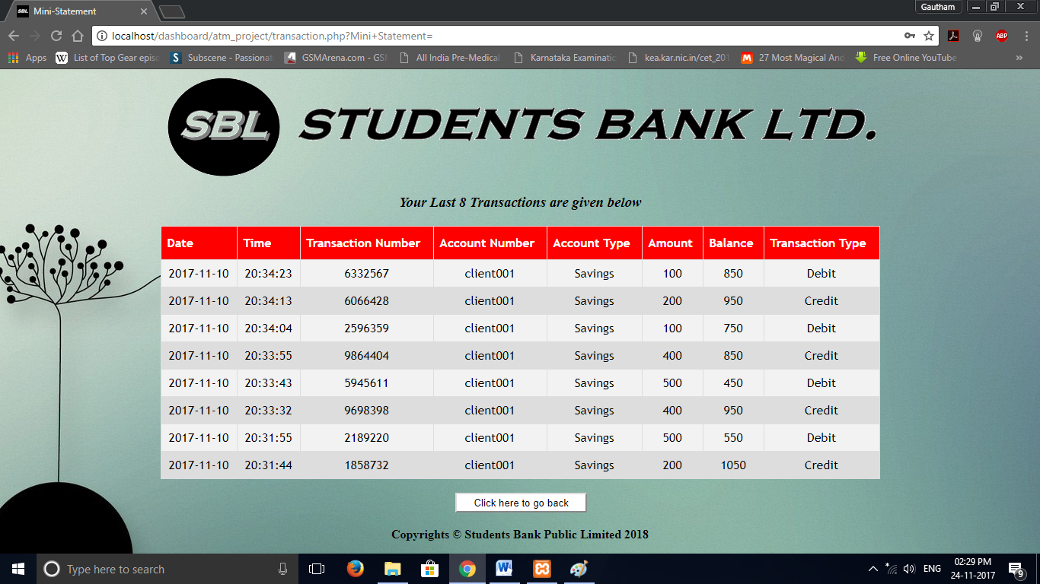

**PIN CHANGE SCREEN:**

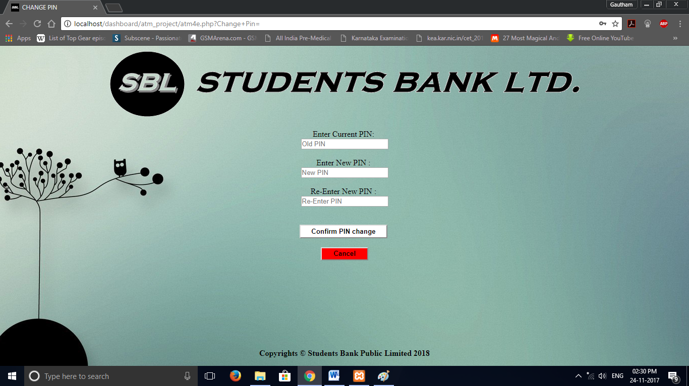

**SIGN UP SCREEN:**

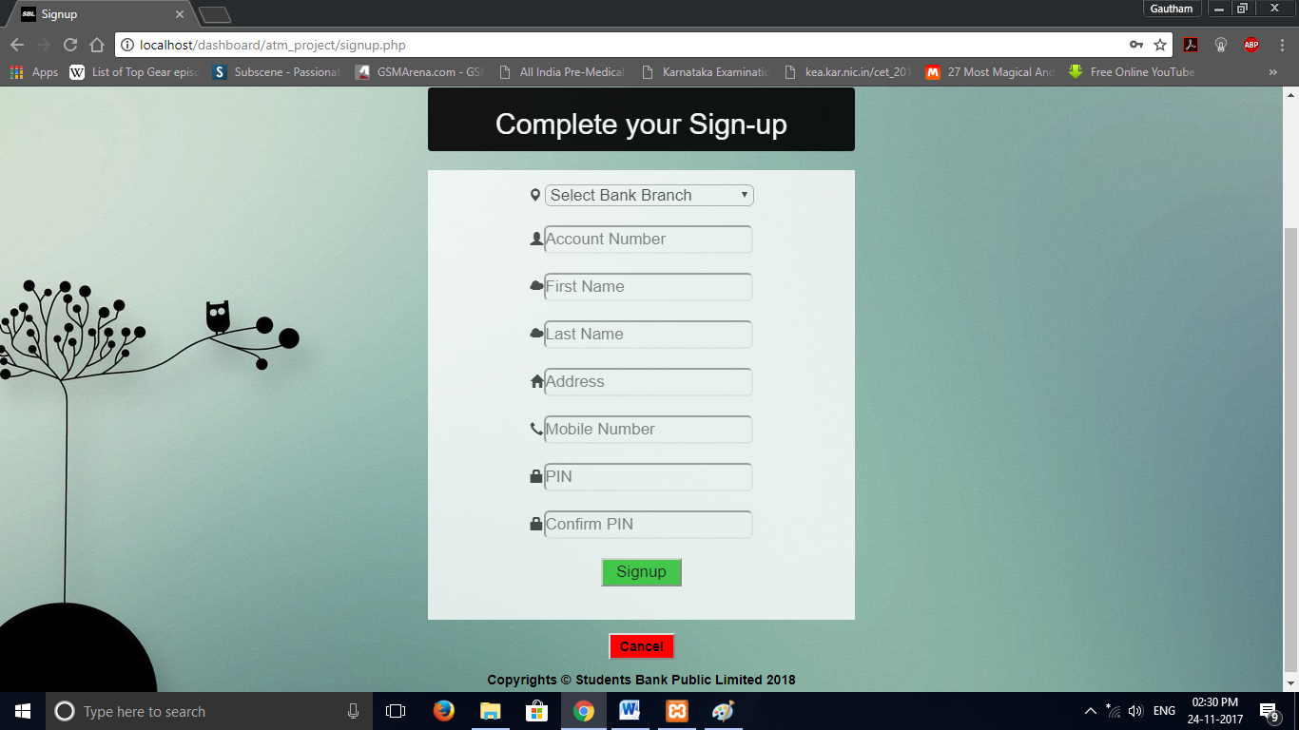

# TABLE OF CONTENTS

Certificate 1

Acknowledgement 2

Abstract 3

1. INTRODUCTION 4

1.1 INTRODUCTION TO DBMS 4

1.1.1 SQL PROGRAMMING 4

1.1.2 Working with SQL COMMANDS 5

1.2 BRIEF OUTLINE OF THE PROJECT 6

2. REQUIREMENT SPECIFICATIONS 7

2.1 EXTERNAL INTERFACE REQUIREMENTS 7

2.2 FUNCTIONAL REQUIREMENTS 8

3.SYSTEM DESIGN……………………………………………………………9

3.1 ER DIAGRAM 15

3.3 USER INTERFACE DESIGN 18

4. DETAILED DESIGN 19

4.1 DATABASE CREATION 19

4.1.1 Data Definitions 19

4.1.2.constraints………………………………………………………………….

4.2.STORED PROCEDURES 20

4.3.TRIGGERS

**5.DATABASE CONNECTIONS & CODE IMPLEMENTATION**………………………….14

5.1 Retrieving data from the database……………………………….......................................19

5.2 Inserting data into the database…………………………………….................................22

5.3 Updating records into the database……………………………………………………….24

6. System and Database Testing 26

6.1  TEST RESULTS/SNAPSHOTS 28

7. CONCLUSION AND SCOPE FOR FURTHER ENHANCEMENTS 34

8. APPENDIX 35

8.1APPENDIX-I 35

8.1.1 Bibliography 35

8.2 APPENDIX-II 36

8.2.1 Development Tools 36

8.2.2 Software Environment 36

8.2.3 Hardware Environment 36

# 8. APPENDIX

**8.1APPENDIX-I**

### 8.1.1 Bibliography

**8.1.1.1 Reference Books/Papers**

**8.1.1.2 Web Sites**

**8.2 APPENDIX-II**

### 8.2.1 Development Tools

### 8.2.2 Software Environment

### 8.2.3 Hardware Environment

|  |  |
| --- | --- |
| **System** | |
| Manufacturer | HP |
| Model | HP Pavilion g6 Notebook PC |
| Total amount of system memory | 4.00 GB RAM |
| System type | 64-bit Operating System |
| Processor | Intel® Core i5-3230 CPU 4 x 2.60 GHz |
| **Storage** | |
| Total size of hard disk | 500 GB |
| 1. Disk partition (C:) | 40.8 GB Free (371 GB Total) |
| Disk partition (D:) | 2.10 GB Free (16.7 GB Total) |
| Disk partition (H:) | 5 GB Free (34 GB Total) |
|  | |
|  |  |
|  |  |
|  |  |
|  |  |
|  |  |
|  |  |
|  |  |